General Ruled-Surface Generator

Definition
# Source: AI Source: Provided by: [Data Path: Persons Table -> ID Column: 1, Name_En Column: Motasem Essam] -> From: [ChatGPT] on [7/25/2026]
A General Ruled-Surface Generator is a straight line that moves through three-dimensional space according to a prescribed geometric rule, producing a surface composed entirely of straight-line elements.
The generated surface is called a Ruled Surface, and each straight line lying on that surface is called a Generator, Generatrix, or Ruling.
Unlike cylindrical and conical generators:
- A cylindrical generator moves while maintaining a constant direction.
- A conical generator moves while passing through a fixed vertex.
- A general ruled-surface generator can change both its position and direction according to a prescribed motion.
This allows it to generate a much wider variety of surfaces, including hyperbolic paraboloids, hyperboloids of one sheet, helicoids, and conoids.
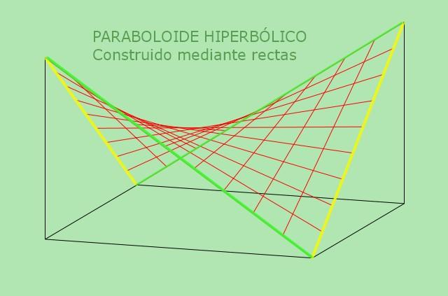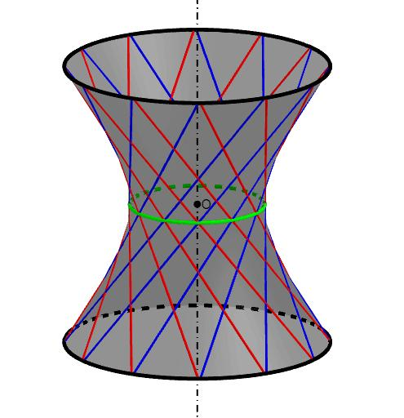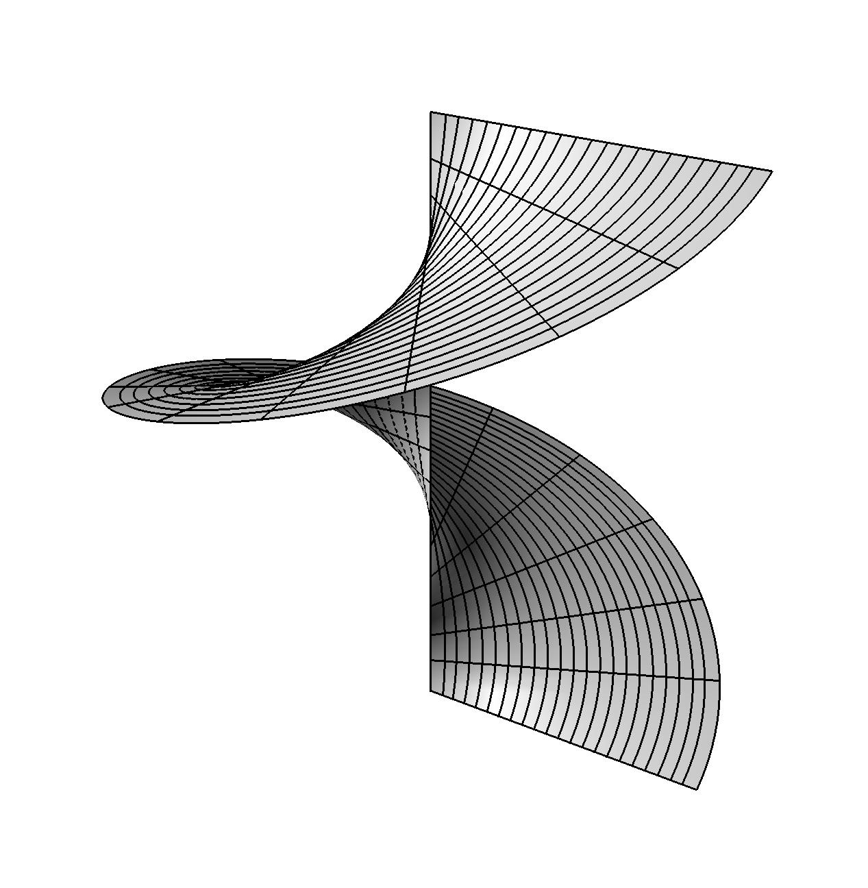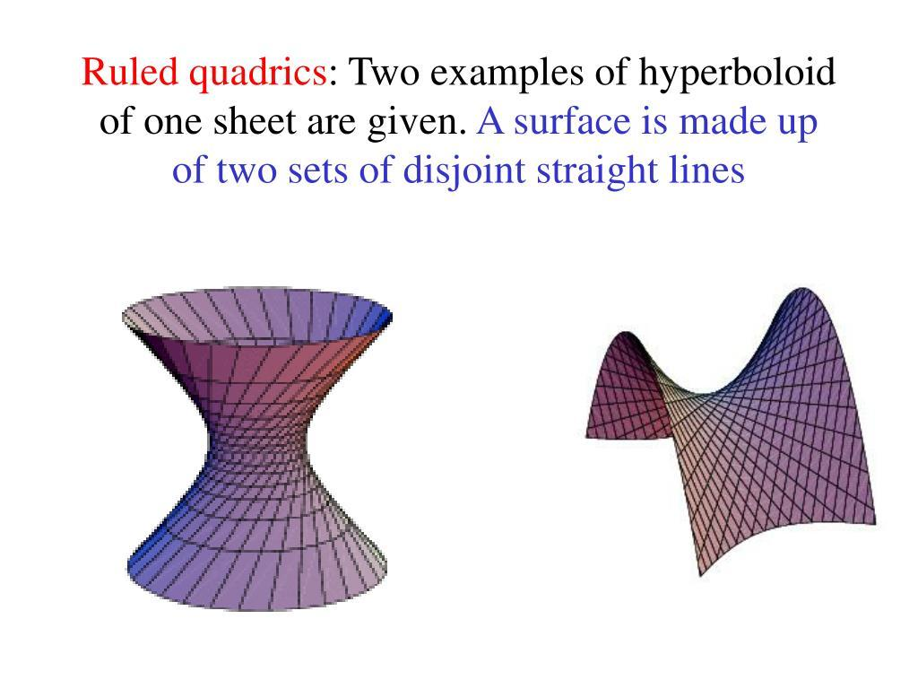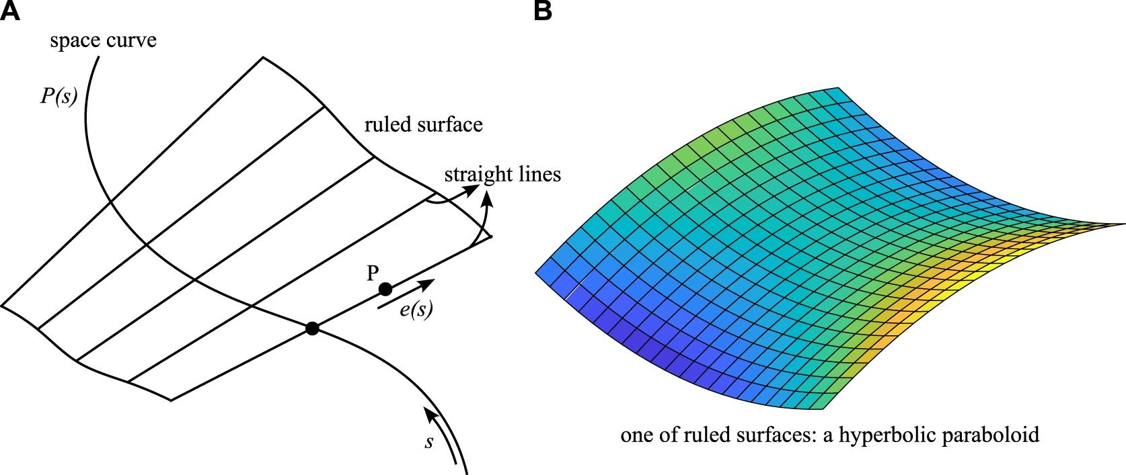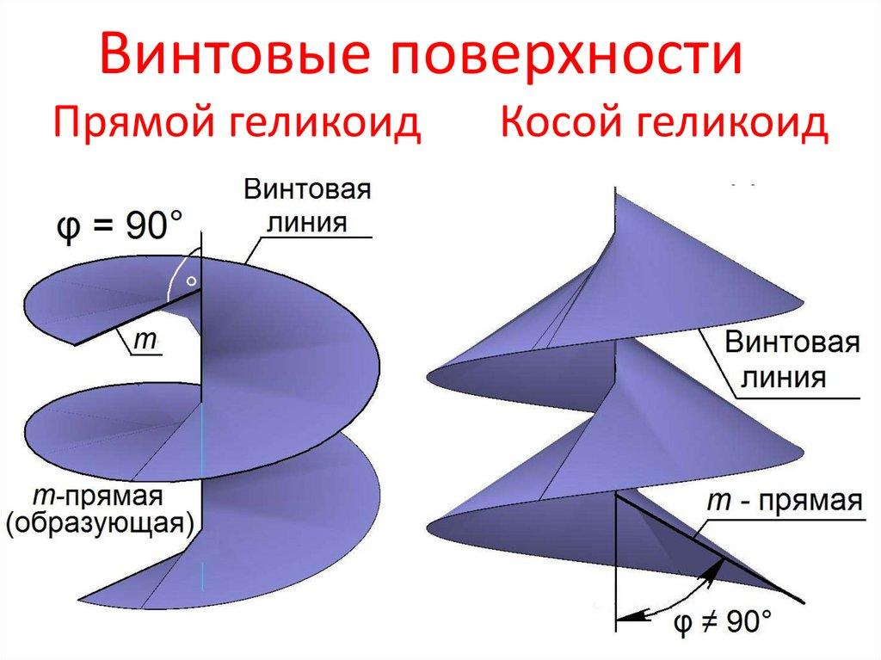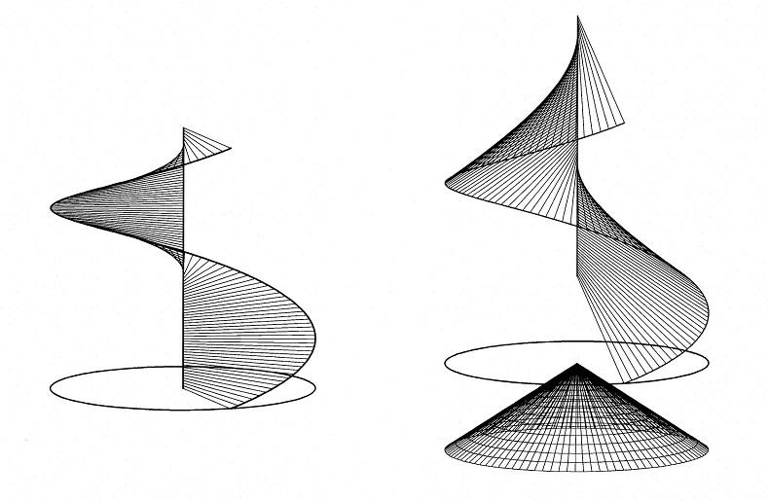

Geometric Structure
# Source: AI Source: Provided by: [Data Path: Persons Table -> ID Column: 1, Name_En Column: Motasem Essam] -> From: [ChatGPT] on [7/25/2026]
A general ruled-surface generator consists of the following elements:
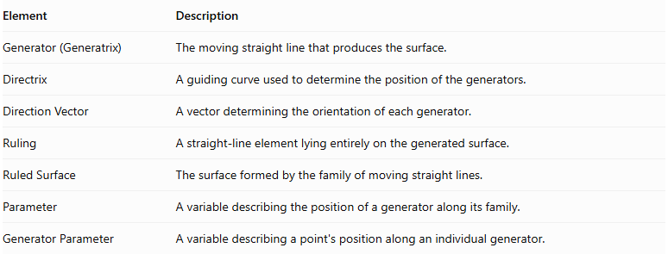
Element | Description
Generator (Generatrix) | The moving straight line that produces the surface.
Directrix | A guiding curve used to determine the position of the generators.
Direction Vector | A vector determining the orientation of each generator.
Ruling | A straight-line element lying entirely on the generated surface.
Ruled Surface | The surface formed by the family of moving straight lines.
Parameter | A variable describing the position of a generator along its family.
Generator Parameter | A variable describing a point's position along an individual generator.

Mathematical Representation
# Source: AI Source: Provided by: [Data Path: Persons Table -> ID Column: 1, Name_En Column: Motasem Essam] -> From: [ChatGPT] on [7/25/2026]
A general ruled surface can be represented by the following vector equation:
$$\boxed{ X(u,v)= C(u)+v D(u)}$$
Where:
- $X(u,v)$: Position vector of a point on the surface.
- $C(u)$: Directrix or reference curve.
- $D(u)$: Direction vector of the generator.
- $u$: Parameter identifying an individual generator.
- $v$: Parameter identifying a point along that generator.
For each fixed value of $u$, the equation describes a straight line.
Interpretation:
- When $v=0$, the point lies on the directrix.
- When $v=1$, the point is displaced by one direction vector from the directrix.
- When $v$ varies, the point moves along the same straight-line generator.
- When $u$ varies, the generator changes its position and potentially its direction.
The family of all these lines forms the ruled surface.

Main Types of General Ruled Surfaces
# Source: AI Source: Provided by: [Data Path: Persons Table -> ID Column: 1, Name_En Column: Motasem Essam] -> From: [ChatGPT] on [7/25/2026]
General ruled surfaces can be classified according to how their generators intersect and how the surface can be developed into a plane.

Developable Ruled Surfaces
# Source: AI Source: Provided by: [Data Path: Persons Table -> ID Column: 1, Name_En Column: Motasem Essam] -> From: [ChatGPT] on [7/25/2026]
A Developable Ruled Surface is a ruled surface that can be unfolded or flattened onto a plane without stretching or tearing.
Its neighboring generators intersect or become parallel in the limiting geometric sense.
Characteristics:
- Can be developed into a plane without distortion.
- Has zero Gaussian curvature at regular points.
- Its tangent plane remains constant along each ruling.
- Used in sheet-metal design, pattern making, and geometric construction.
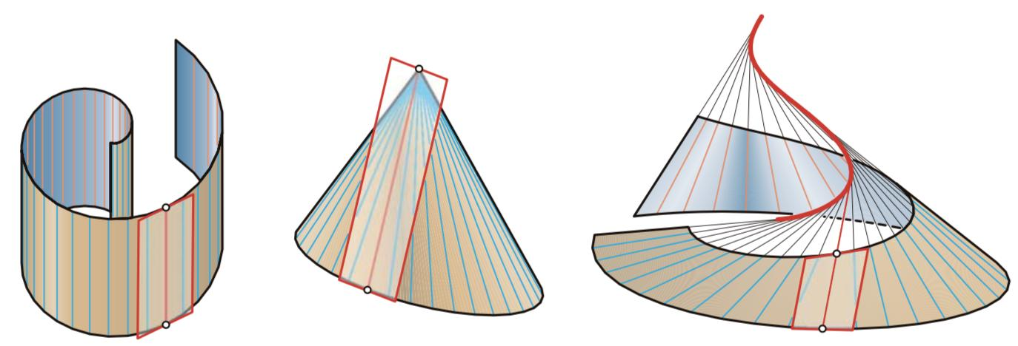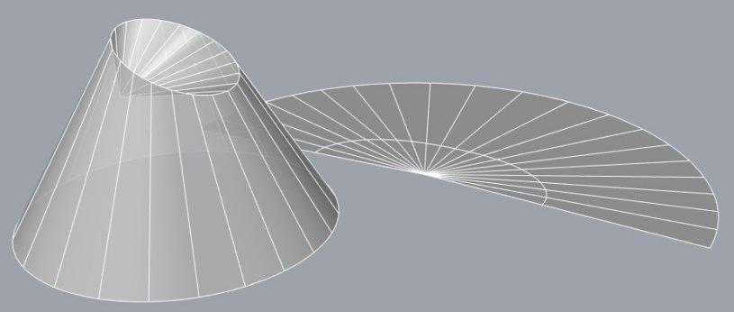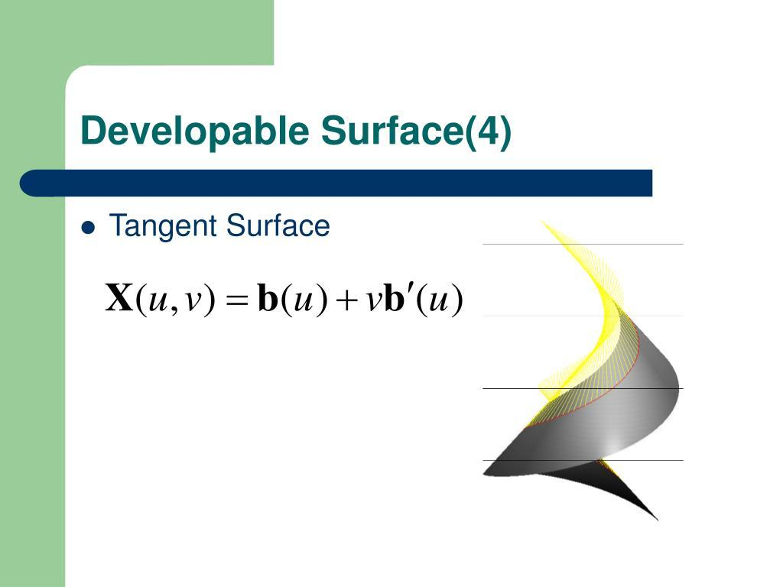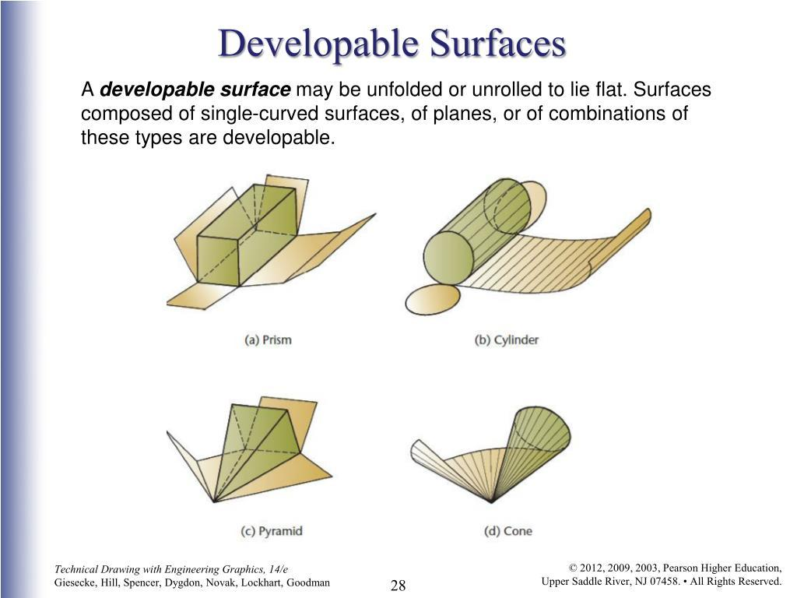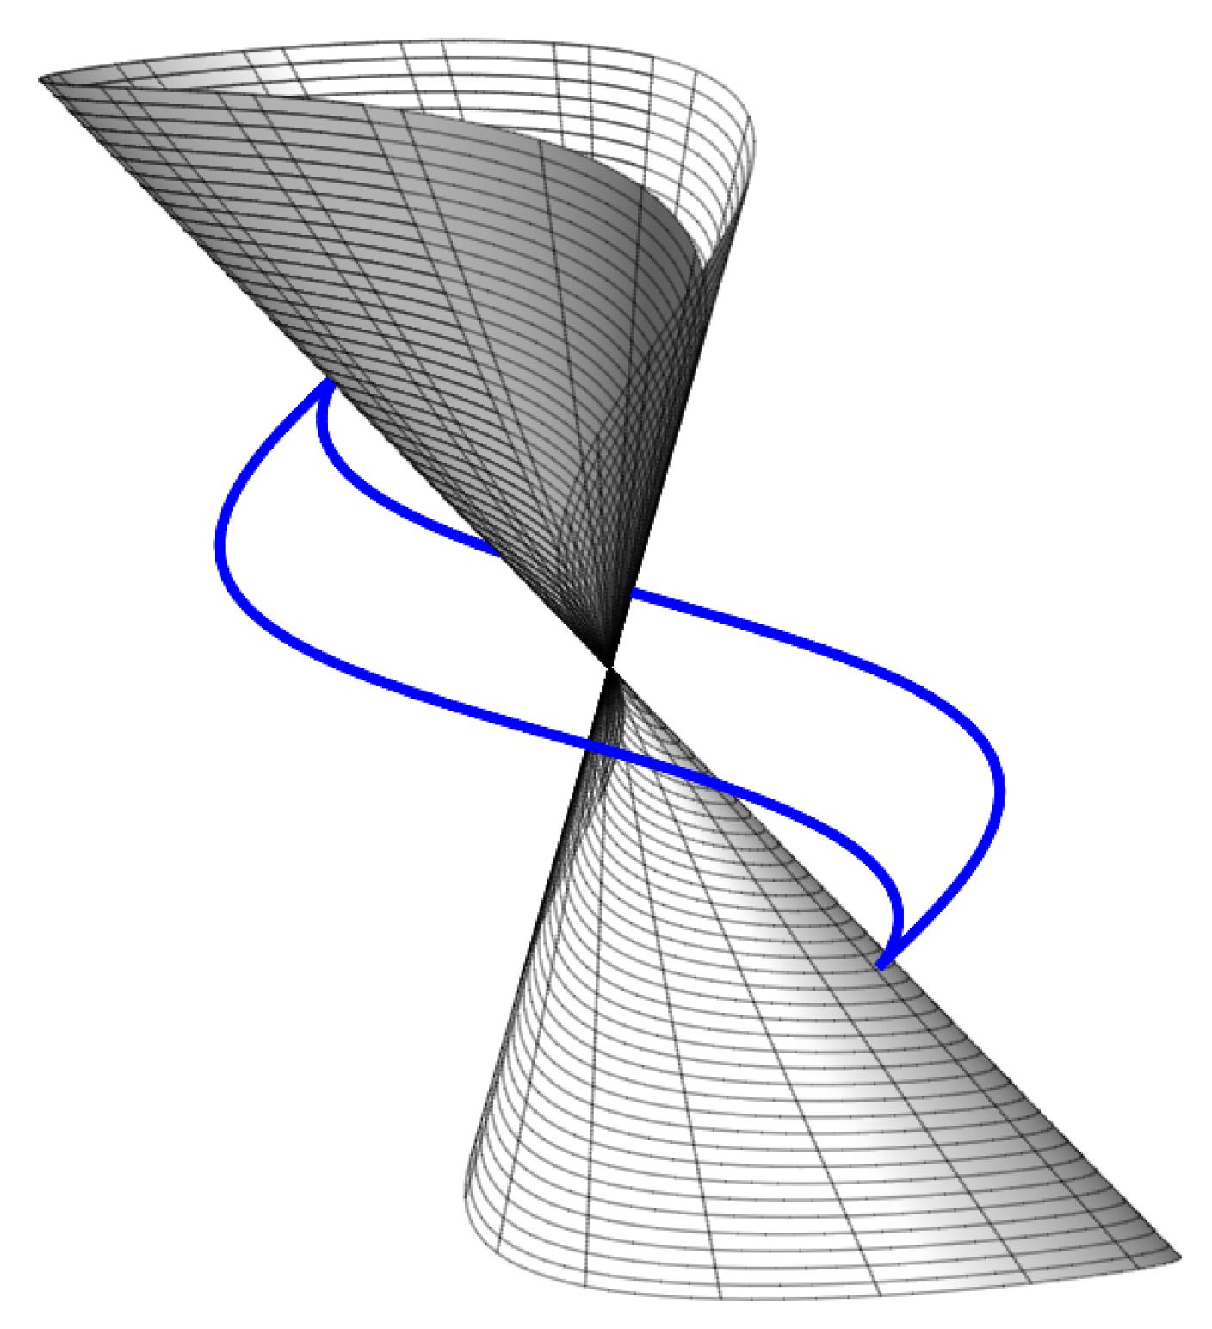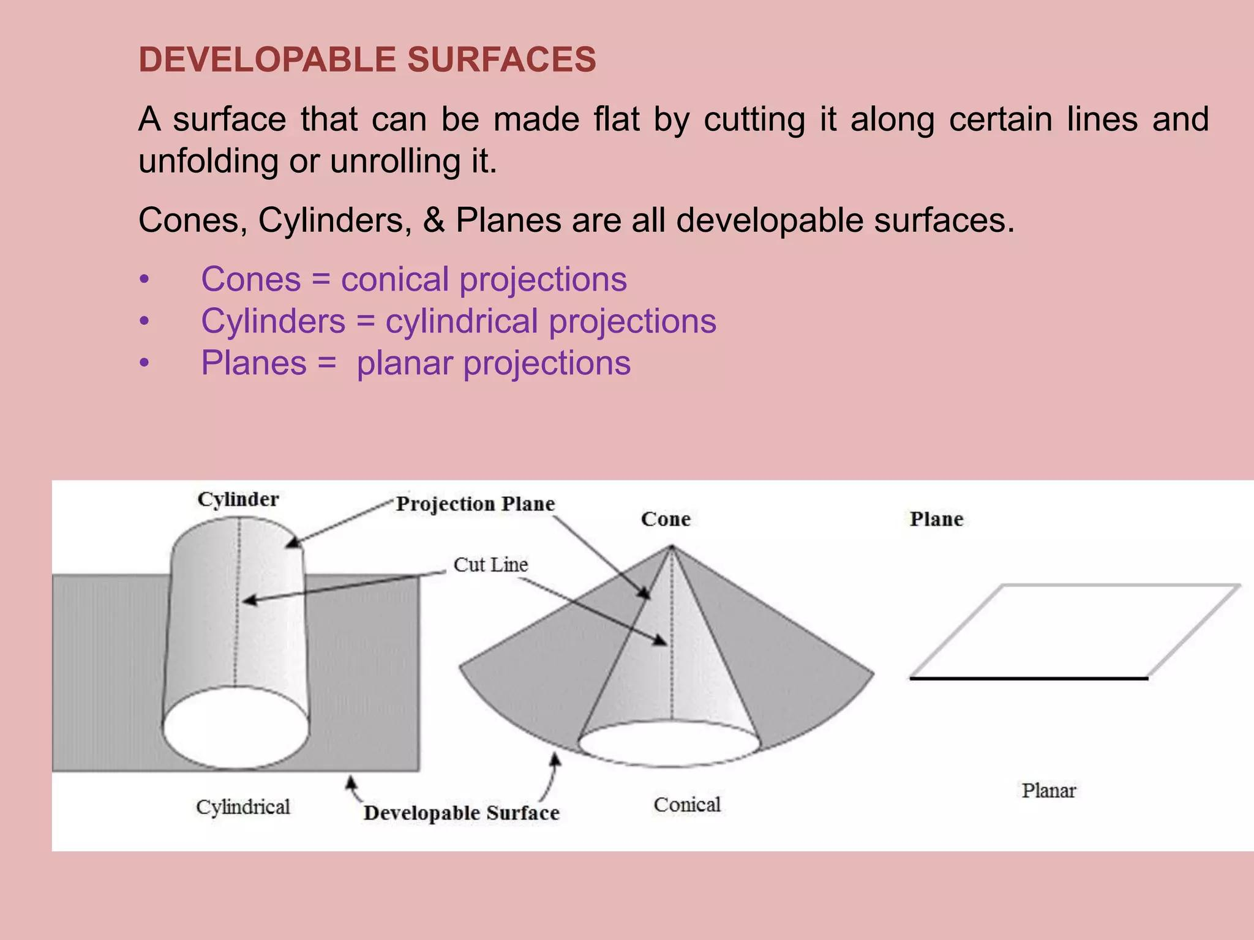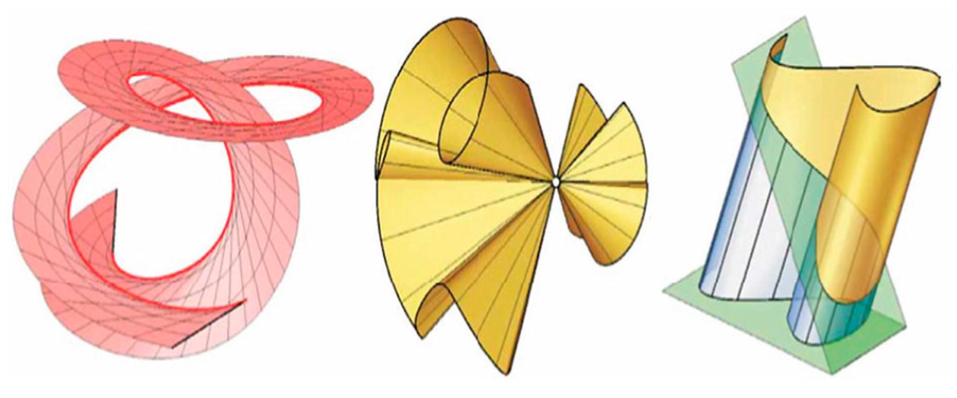
Main types:
- Cylindrical Developable Surface
- Conical Developable Surface
- Tangent Developable Surface

Non-Developable Ruled Surfaces
# Source: AI Source: Provided by: [Data Path: Persons Table -> ID Column: 1, Name_En Column: Motasem Essam] -> From: [ChatGPT] on [7/25/2026]
A Non-Developable Ruled Surface is a ruled surface that cannot be flattened onto a plane without distortion.
Its neighboring generators generally do not intersect.
Characteristics:
- Has nonzero Gaussian curvature at regular points in general.
- Cannot be unfolded into a plane without distortion.
- Generators can be skew to one another.
- Used in architectural structures and geometric surface modeling.
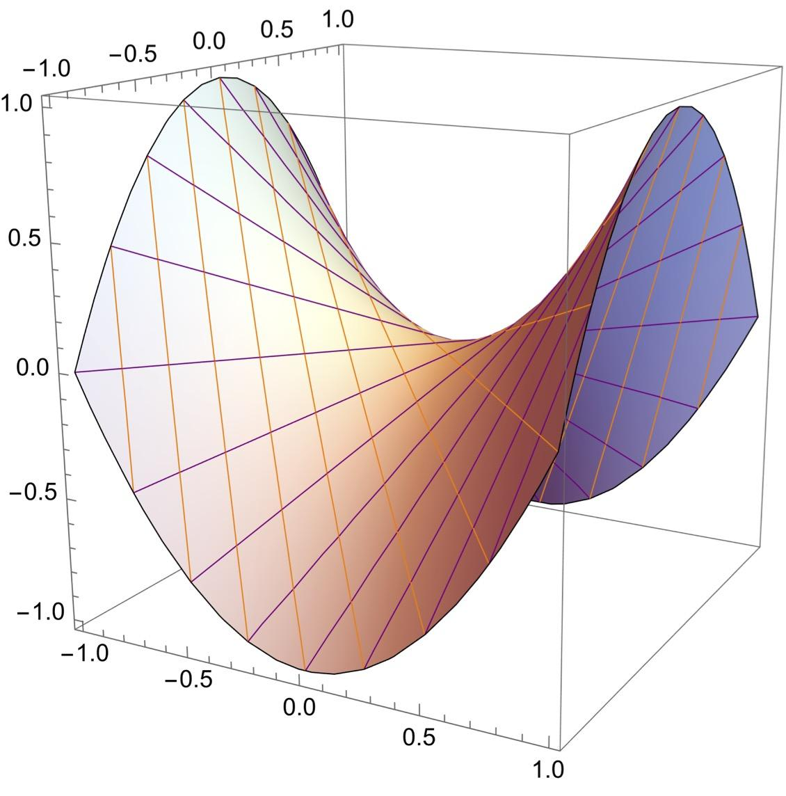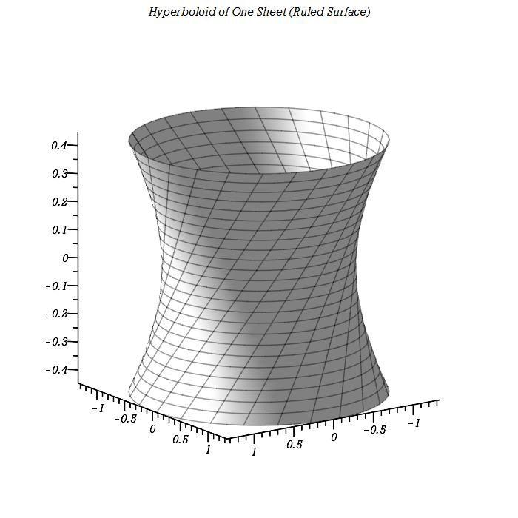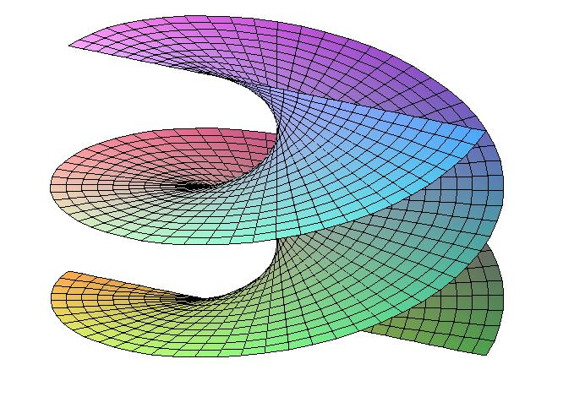
Main examples:
- Hyperbolic Paraboloid
- Hyperboloid of One Sheet
- Helicoid
- Non-Developable Conoids

Singly Ruled Surfaces
# Source: AI Source: Provided by: [Data Path: Persons Table -> ID Column: 1, Name_En Column: Motasem Essam] -> From: [ChatGPT] on [7/25/2026]
A Singly Ruled Surface is a ruled surface that has one family of straight-line generators through a general point of the surface.
Characteristics:
- Has one principal family of rulings.
- The generators may change their position and direction.
- Examples include many cones, cylinders, and helicoids.

Doubly Ruled Surfaces
# Source: AI Source: Provided by: [Data Path: Persons Table -> ID Column: 1, Name_En Column: Motasem Essam] -> From: [ChatGPT] on [7/25/2026]
A Doubly Ruled Surface is a surface that contains two distinct families of straight-line generators, with two different ruling lines passing through a general point.
Characteristics:
- Contains two distinct families of straight lines.
- Each family generates the same surface.
- A line from one family generally intersects lines from the other family.
- The generators within the same family are generally skew.
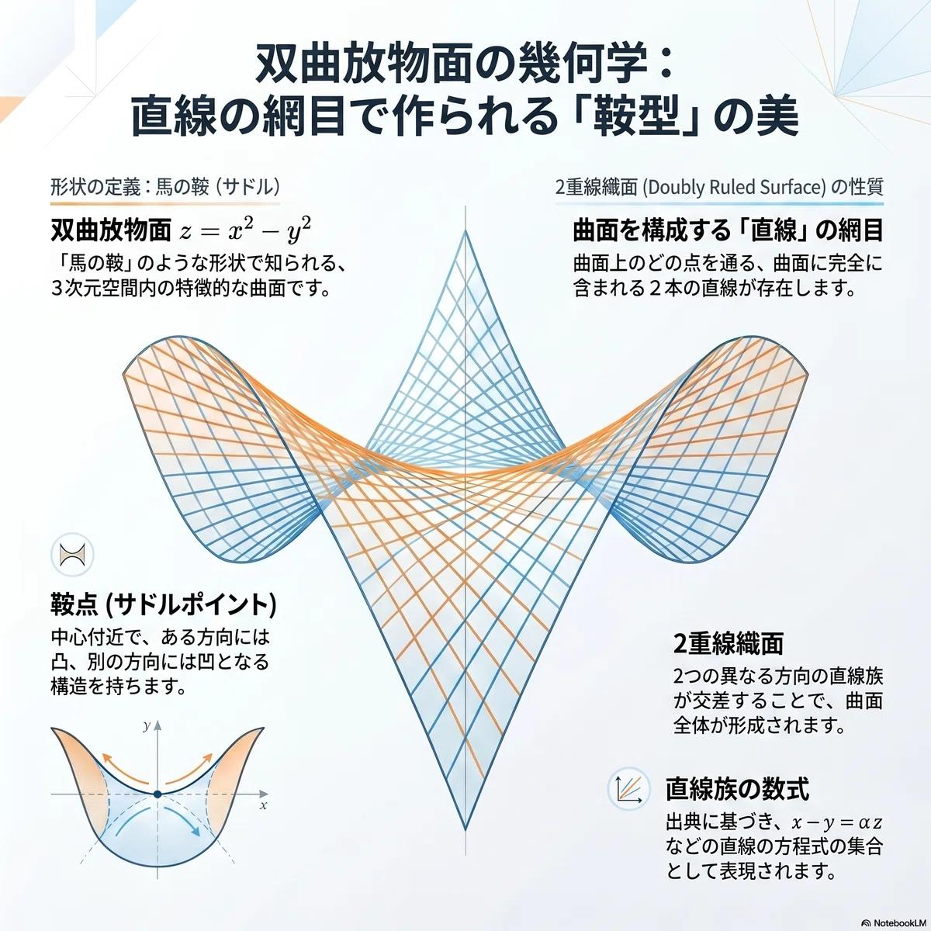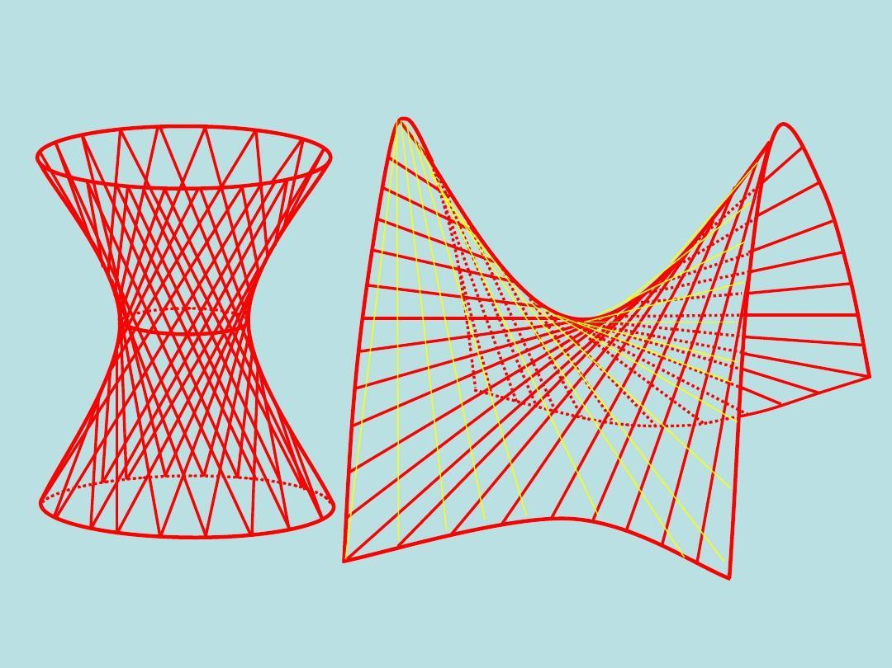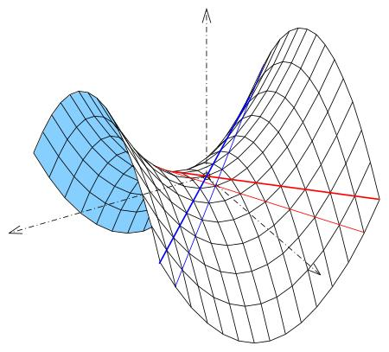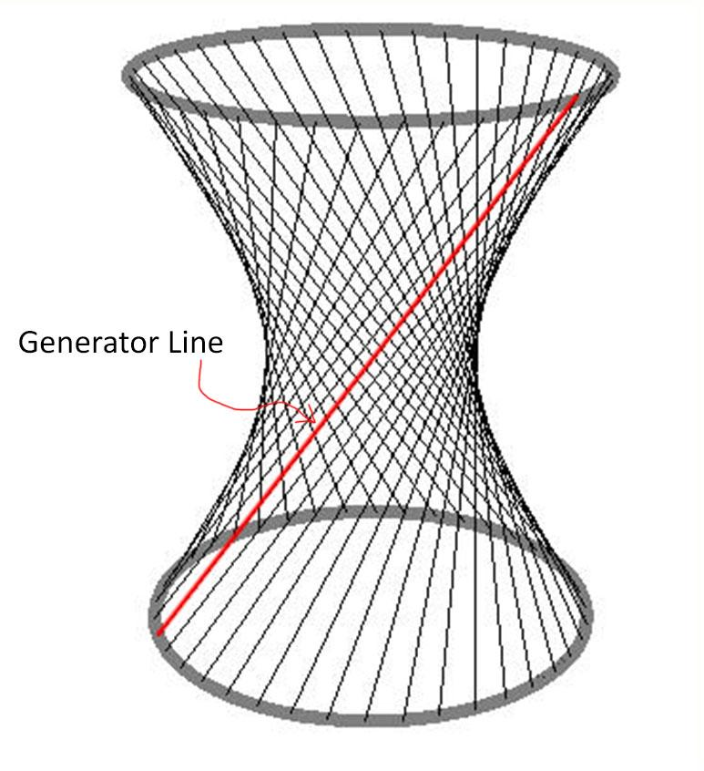
Main examples:
- Hyperbolic Paraboloid
- Hyperboloid of One Sheet
These are important examples of doubly ruled quadric surfaces.

Examples of General Ruled Surfaces

Hyperbolic Paraboloid
# Source: AI Source: Provided by: [Data Path: Persons Table -> ID Column: 1, Name_En Column: Motasem Essam] -> From: [ChatGPT] on [7/25/2026]
A Hyperbolic Paraboloid is a saddle-shaped ruled surface that contains two distinct families of straight-line generators.
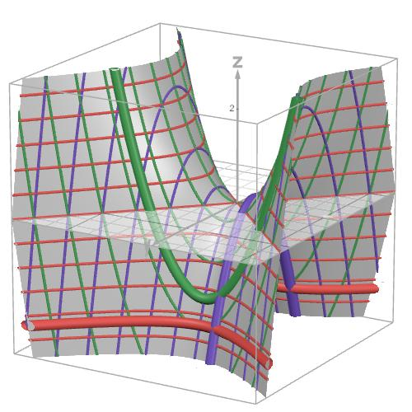
Its standard equation is:
$$z=\frac{x^{2}}{a^{2}}-\frac{y^{2}}{b^{2}}$$
An alternative form, after a suitable coordinate transformation and scaling, is:
$$z=xy$$
Characteristics:
- Doubly ruled surface.
- Non-developable surface.
- Saddle-shaped geometry.
- Contains two families of straight-line generators.

Hyperboloid of One Sheet
# Source: AI Source: Provided by: [Data Path: Persons Table -> ID Column: 1, Name_En Column: Motasem Essam] -> From: [ChatGPT] on [7/25/2026]
A Hyperboloid of One Sheet is a curved surface that can be generated by two distinct families of straight lines.
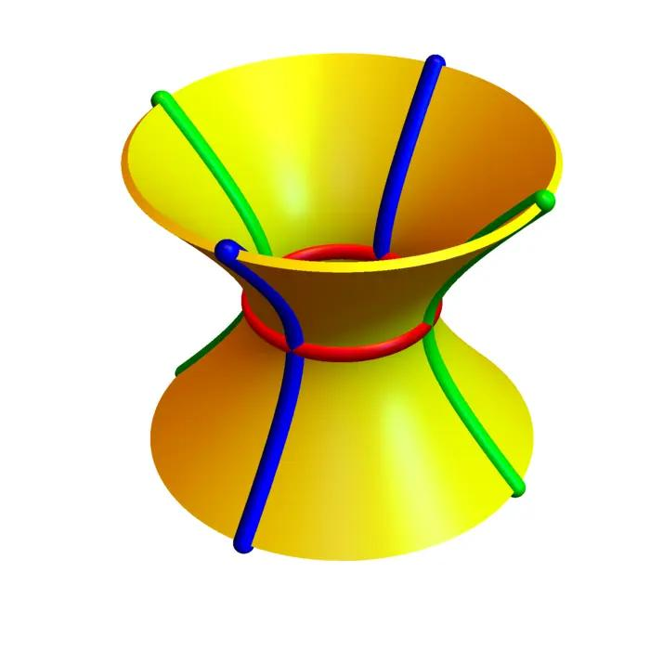
Its standard equation is:
$$\frac{x^{2}}{a^{2}}+\frac{y^{2}}{b^{2}}-\frac{z^{2}}{c^{2}}=1$$
Characteristics:
- Doubly ruled surface.
- Non-developable surface.
- Has a continuous connected shape.
- Contains two distinct families of straight-line generators.

Helicoid
# Source: AI Source: Provided by: [Data Path: Persons Table -> ID Column: 1, Name_En Column: Motasem Essam] -> From: [ChatGPT] on [7/25/2026]
A Helicoid is a spiral-shaped ruled surface generated by a straight line that rotates around an axis while simultaneously translating along that axis.
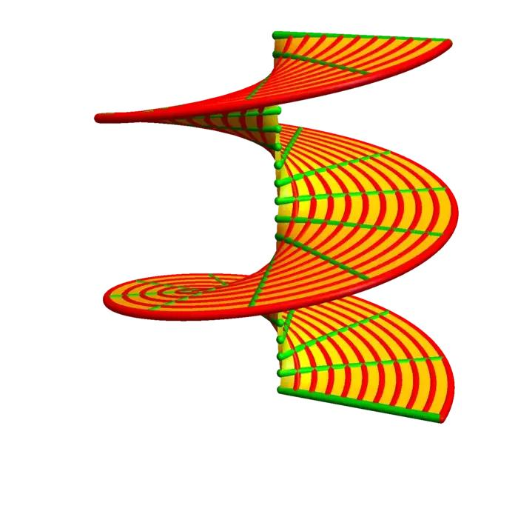
A standard parametrization is:
$$x=vcosu$$
$$y=vsinu$$
$$z=cu$$
Where:
- $u$: Rotation parameter.
- $v$: Position along the generating line.
- $c$: Constant controlling the vertical translation.
Characteristics:
- Ruled surface.
- Generally non-developable.
- Has a spiral structure.
- Used in the mathematical modeling of spiral staircases and screw-like surfaces.

Conoid
# Source: AI Source: Provided by: [Data Path: Persons Table -> ID Column: 1, Name_En Column: Motasem Essam] -> From: [ChatGPT] on [7/25/2026]
A Conoid is a ruled surface whose generators satisfy a particular arrangement involving a straight-line directrix and a guiding curve or plane.
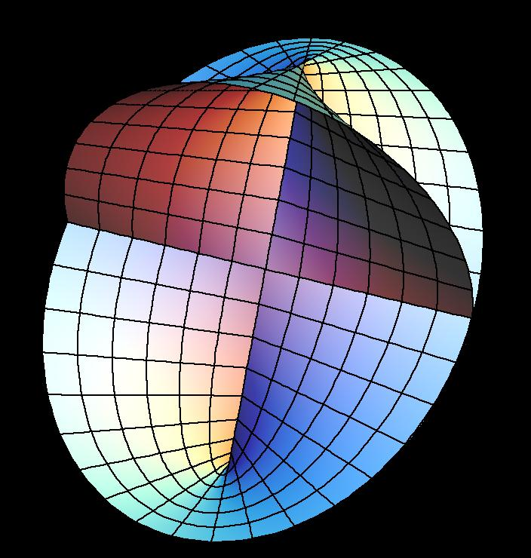
Characteristics:
- Formed by a family of straight-line generators.
- Can have a curved or twisted appearance.
- Some conoids are developable, while others are non-developable.
- A right conoid is a particular form in which the generating lines satisfy an additional perpendicularity condition.

Tangent Developable Surface
# Source: AI Source: Provided by: [Data Path: Persons Table -> ID Column: 1, Name_En Column: Motasem Essam] -> From: [ChatGPT] on [7/25/2026]
A Tangent Developable Surface is generated by the tangent lines of a space curve.
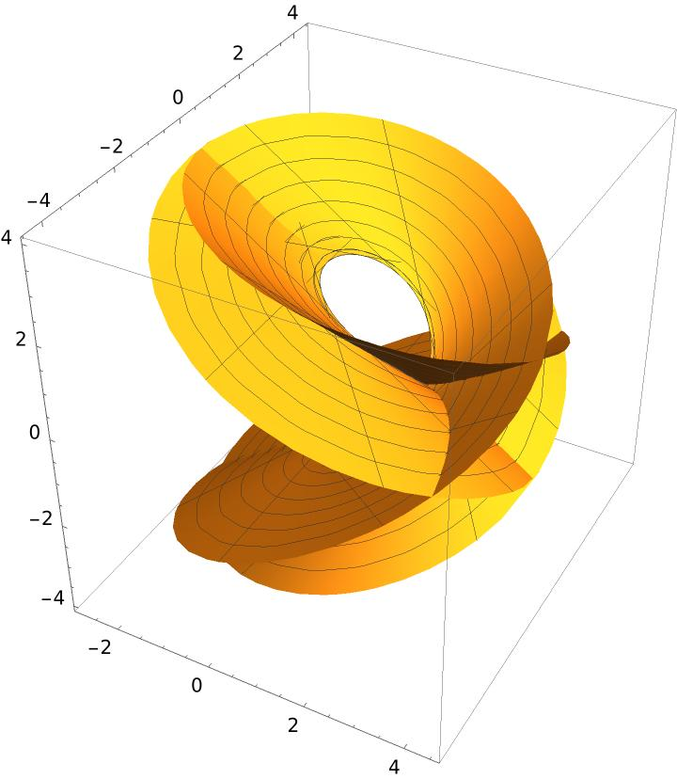
Its parametric representation is:
$$X(u,v)= C(u)+v C'(u)$$
Where:
- $C(u)$: Position vector of the directrix curve.
- $C'(u)$: Tangent vector to the curve.
- $v$: Position along each tangent line.
Characteristics:
- Developable ruled surface.
- Each generator is tangent to the directrix curve.
- The generators form a surface along the curve.
- It may have singularities, depending on the curve.

Mathematical Properties
# Source: AI Source: Provided by: [Data Path: Persons Table -> ID Column: 1, Name_En Column: Motasem Essam] -> From: [ChatGPT] on [7/25/2026]
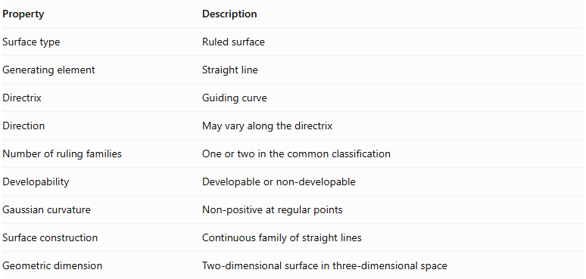
Property | Description
Surface type | Ruled surface
Generating element | Straight line
Directrix | Guiding curve
Direction | May vary along the directrix
Number of ruling families | One or two in the common classification
Developability | Developable or non-developable
Gaussian curvature | Non-positive at regular points
Surface construction | Continuous family of straight lines
Geometric dimension | Two-dimensional surface in three-dimensional space
Important mathematical property:
For a regular ruled surface, its Gaussian curvature $K$ satisfies:
$$\boxed{K≤0}$$
- $K=0$: Developable ruled surface at regular points.
- $K<0$: Non-developable ruled surface at points of negative curvature.

Comparison of Ruled-Surface Types
# Source: AI Source: Provided by: [Data Path: Persons Table -> ID Column: 1, Name_En Column: Motasem Essam] -> From: [ChatGPT] on [7/25/2026]
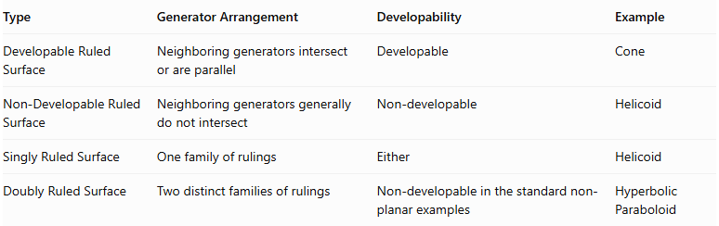
Type | Generator Arrangement | Developability | Example
Developable Ruled Surface | Neighboring generators intersect or are parallel | Developable | Cone
Non-Developable Ruled Surface | Neighboring generators generally do not intersect | Non-developable | Helicoid
Singly Ruled Surface | One family of rulings | Either | Helicoid
Doubly Ruled Surface | Two distinct families of rulings | Non-developable in the standard non-planar examples | Hyperbolic Paraboloid
Classification note: Developability and the number of ruling families are two separate classification criteria. A surface can be classified according to both properties; they should not be treated as one mutually exclusive list.

Applications
# Source: AI Source: Provided by: [Data Path: Persons Table -> ID Column: 1, Name_En Column: Motasem Essam] -> From: [ChatGPT] on [7/25/2026]
General ruled surfaces are useful in several fields:
- Architecture: Hyperbolic paraboloids are used in roof and shell structures.
- Engineering: Ruled surfaces are used in mechanical components and structural frameworks.
- Industrial Design: Straight-line elements simplify the modeling and manufacturing of curved surfaces.
- Computer-Aided Design (CAD): Ruled surfaces are used to construct and represent complex three-dimensional shapes.
- Descriptive Geometry: They help represent and analyze surfaces formed by moving straight lines.

Main Classification
# Source: AI Source: Provided by: [Data Path: Persons Table -> ID Column: 1, Name_En Column: Motasem Essam] -> From: [ChatGPT] on [7/25/2026]
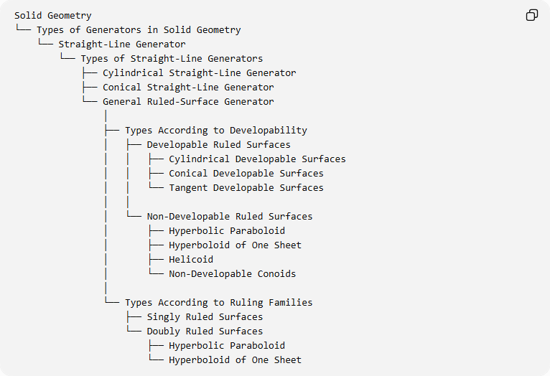
Solid Geometry
└── Types of Generators in Solid Geometry
└── Straight-Line Generator
└── Types of Straight-Line Generators
├── Cylindrical Straight-Line Generator
├── Conical Straight-Line Generator
└── General Ruled-Surface Generator
│
├── Types According to Developability
│ ├── Developable Ruled Surfaces
│ │ ├── Cylindrical Developable Surfaces
│ │ ├── Conical Developable Surfaces
│ │ └── Tangent Developable Surfaces
│ │
│ └── Non-Developable Ruled Surfaces
│ ├── Hyperbolic Paraboloid
│ ├── Hyperboloid of One Sheet
│ ├── Helicoid
│ └── Non-Developable Conoids
│
└── Types According to Ruling Families
├── Singly Ruled Surfaces
└── Doubly Ruled Surfaces
├── Hyperbolic Paraboloid
└── Hyperboloid of One Sheet

Key Points
# Source: AI Source: Provided by: [Data Path: Persons Table -> ID Column: 1, Name_En Column: Motasem Essam] -> From: [ChatGPT] on [7/25/2026]
- A general ruled-surface generator is a moving straight line that produces a ruled surface.
- Its position and direction can change during its movement.
- The directrix and direction vector determine the arrangement of the generators.
- Developable ruled surfaces can be flattened without stretching or tearing.
- Non-developable ruled surfaces cannot be flattened without distortion.
- Doubly ruled surfaces contain two distinct families of straight-line generators.
- Hyperbolic paraboloids and hyperboloids of one sheet are important doubly ruled surfaces.
- Helicoids and tangent developable surfaces are additional examples of ruled surfaces.

Conclusion
# Source: AI Source: Provided by: [Data Path: Persons Table -> ID Column: 1, Name_En Column: Motasem Essam] -> From: [ChatGPT] on [7/25/2026]
The General Ruled-Surface Generator represents the broader category of straight-line generators in solid geometry. It includes generators that move according to different geometric rules, producing a wide range of developable and non-developable surfaces.
Unlike cylindrical and conical generators, it is not restricted to parallel lines or lines passing through one fixed vertex.

